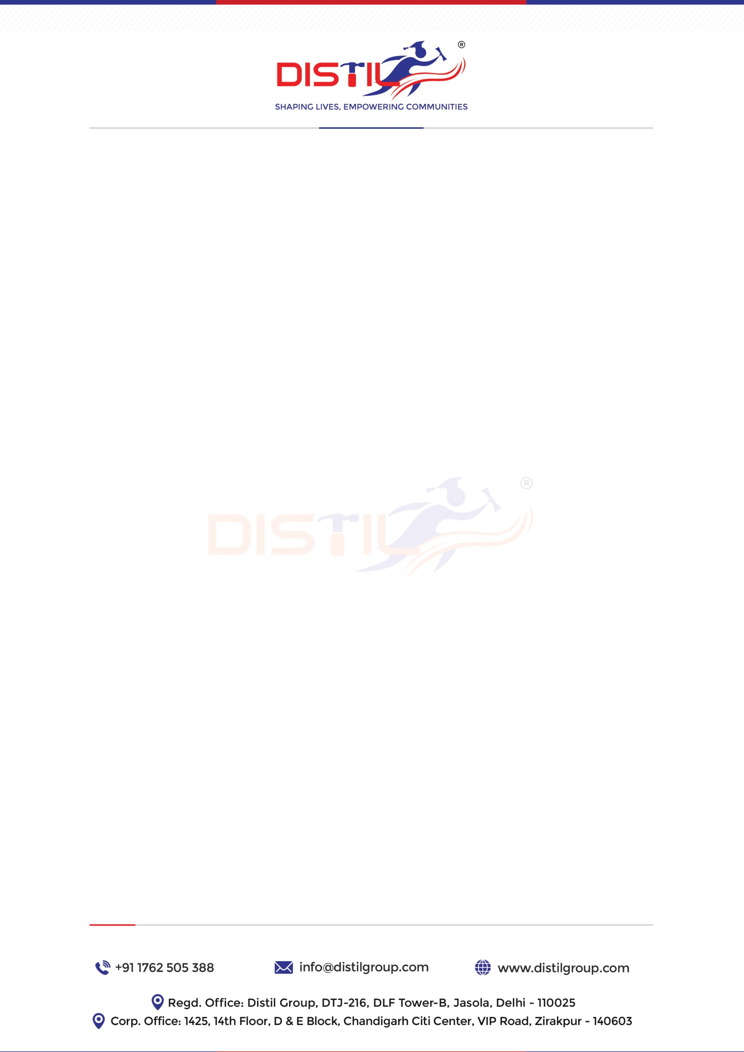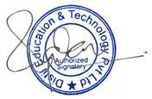

**Letter of Intent** Date: 20/05/2023

Dear Satendra Pal

This is in reference to your application and interview with us; we are pleased to offer you an opportunity for the position of **Assembly Line Operator** at our client location **YAZAKI INDIA PVT LTD – BHIWADI RAJASTHAN 301019,** with effective from the 22th May-23. And your monthly compensation will be **(Stipend - is Rs. 11000/- Per month). Including Attendance Award**.

As a member of Our Organization team, we would ask for your commitment to deliver outstanding quality and results that exceed client expectations. In addition, we expect your personal accountability in all the operations, actions, advice and results that you provide as a representative of Our Organization. In return, we are committed to provide you with every opportunity to learn grow and stretch to the highest level of your ability and potential.

We are confident you will find this new opportunity both challenging and rewarding. The followingpoints outline the terms and conditions we are proposing.

Following the initial probationary period, a progression and performance review will be conducted on a quarterly basis to assess performance to-date, and to clarify or modify this arrangement, as the need may arise.

We look forward to the opportunity to work with you in an atmosphere that is successful and mutually challenging and rewarding.

We warmly welcome you to the **Distil** family and wish you a rewarding career!

**Warm Regards**

**Mr Sudheer Yadav**

Senior Executive – Recruitment

**Mobile:** +91 6392703976